**Class Attendance Mobile App**

Use Case Specification

Submitted to:

Asst. Prof. Ma. Rowena C. Solamo

Faculty Member

Department of Computer Science

College of Engineering

University of the Philippines, Diliman

Submitted by:

Atienza,​ ​John​ Oliver

Austria,​ ​Ronnel​​ Roi

Gabriel,​ ​Kristianne​ Arielle

In partial fulfillment of academic requirements

for the course

CS 191 Software Engineering I

of the

1st Semester, AY 2017-2018

***Unique Reference:***

The documents are stored in the GitHub repository:

<https://github.com/rbaustria/ClassAttendanceMobileApp>

***Document Purpose:***

The document provides the Use Case specification of the software, Class Attendance Mobile App.

***Target Audience:***

The target audience of the document are: the developers of the software, future developers who wish to extend it, and the professor.

***Revision Control***

*History Revision:*

|  |  |  |  |
| --- | --- | --- | --- |
| ***Revision Date*** | ***Person Responsible*** | ***Version***  ***Number*** | ***Modification*** |
| 10/10/17 | Arielle Gabriel | 1.0 | Initial Document |
|  |  |  |  |

*Use-Case Name*: 2.5 Add list of students to class

*Description:* This use-case enables the teacher to add students to an existing class. The process involves the teacher uploading a spreadsheet file containing the list of students to the program. It will then be parsed by the application and the students will be added to a given class.

*Preconditions:* At least one class must be existing

*Flow of Events:*

|  |  |
| --- | --- |
| ***Scenario Name*** | ***Description*** |
| Scenario 1 (Basic Flow)  Teacher adds a list of students to the class | 1. Teacher selects a class from the list of existing classes. 2. He/she will click the upload class list button then attaches a spreadsheet file containing the information about the students. 3. The program will process the spreadsheet file then checks if the data is valid. 4. If there are no complications, the students are added to the selected class. |
| Scenario 2  Teacher failes to add a list of students to the class | 1. Teacher selects a class from the list of existing classes. 2. He/she will click the upload class list button then attaches a spreadsheet file containing the information about the students. 3. The program will process the spreadsheet file then checks if the data is valid. 4. If there are complications, an error will be displayed and the nothing will be added to the class. |

*Activity Diagram of the Flow of Events:*

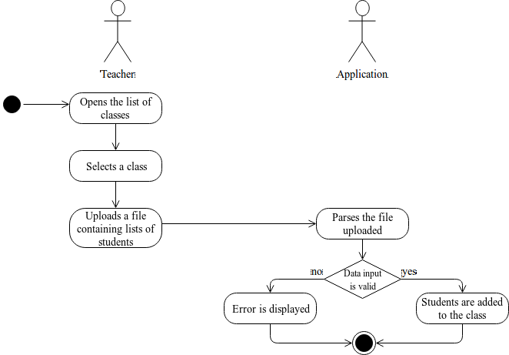

*Postcondition:* Students listed in the spreadsheet are added to the class

*Relationships:* NONE

*Special Requirements:*

Spreadsheet file must be formatted in a specific way so it can be parsed correctly by the program.